Tel: 3486 3018
Mobile / Whatsapp: 9438 4535
E-mail: fairchoicehk@gmail.com

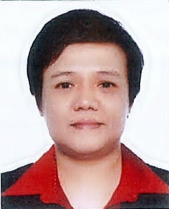

PERSONAL DATA

Name | Joan B. Dasigan | Civil Status | Single
Gender | Female | No of children | -
Nationality | Filipino | Age of children | -
Date of Birth | February 27, 1979 | Age | 38
Place of Birth | Manila, Philippines | Height | 5’
Religion | Catholic | Weight | 120 lbs

Elementary | CAA Laspinas Elementary School | 1992
High School | Laspinas Municipal High School | 1996
Other | Cantonese Course | 2016
Other | Chinese Cooking Course | 2017
EDUCATIONAL BACKGROUND YEAR

LANGUAGE PROFICIENCY

 | Language | READ | WRITE | SPEAK
1 | Tagalog
2 | English
3
4

PAST EMPLOYMENT EXPERIENCE

Name and contact no of Employer | Location | From | To | Duties | Reason for Leaving
Michael Guy | Philippines | 2012 | 2016 | General Household Chores, Cooking | Apply for work in  Hong Kong

NON-DOMESTIC EMPLOYMENT EXPERIENCE

Company/Employer | Location | From | To | Job Title /Duties
LSYOOS Parlor | Manila | 1998 | 2012 | Hair Stylist

SUPPLEMENTARY INFORMATION
 | Yes | No
Willing to take care of new born babies
Willing to take care of children
Willing to take care of elderly
Willing to take care of male disabled person/elderly*
Willing to take care of female disabled person/elderly*
Willing to take care of pets
Willing to change day off
Known medical conditions (please specify below)
*Including bathing and help going to toilet/changing diapers

Available to start on:

Immediately
_________________________________________

Visa situation: No visa, overseas hire from the Philippines

Have References? No

