Tel: 3486 3018
Mobile / Whatsapp: 9438 4535
E-mail: fairchoicehk@gmail.com

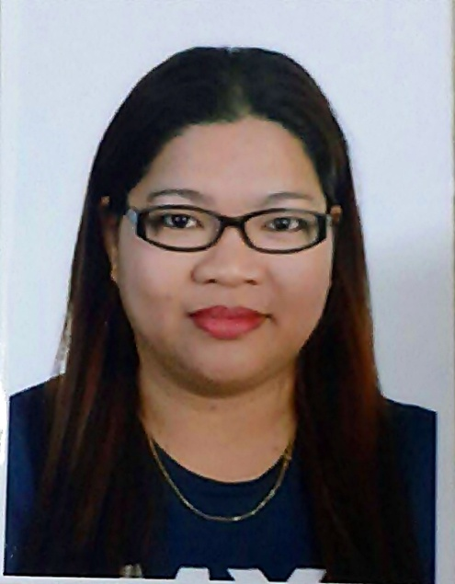

PERSONAL DATA

Name | Angelita Aquino | Civil Status | Married
Gender | Female | No of children | 1
Nationality | Filipino | Age of children | 11
Date of Birth | August 23, 1982 | Age | 35
Place of Birth | Quezon, Philippines | Height | 5’4”
Religion | Roman Catholic | Weight | 75 kg

Elementary | San Andres II Elementary School | 1995
High School | Dominican High School | 1999
College | Araullo University | 2004
Other
EDUCATIONAL BACKGROUND YEAR

SKILLS

Cleaning, Baby care, Childcare, Cooking, Petcare, Gardening

PREFERRED DUTIES

Childcare, Petcare, Helping children with studies/homework

LANGUAGE PROFICIENCY

 | Language | READ | WRITE | SPEAK
1 | English
2 | Filipino
3
4

PAST EMPLOYMENT EXPERIENCE

Name and contact no of Employer | Location | From | To | Duties | Reason for Leaving
Venu Shaitri Alo Sangaran | Malaysia | 2012 | 2017 | Childcare, General Household Chores, Cooking (Indian food) | Finished Contract

NON-DOMESTIC EMPLOYMENT EXPERIENCE

Company/Employer | Location | From | To | Job Title /Duties

INTERESTES / HOBBIES

Taking care of her dogs

SUPPLEMENTARY INFORMATION
 | Yes | No
Willing to take care of new born babies
Willing to take care of children
Willing to take care of elderly
Willing to take care of male disabled person/elderly*
Willing to take care of female disabled person/elderly*
Willing to take care of pets
Willing to change day off
Known medical conditions (please specify below)
*Including bathing and help going to toilet/changing diapers

Available to start on:

Immediately
_________________________________________

Visa situation: No visa, overseas hire from the Philippines

Have References? No

