Tel: 3486 3018
Mobile / Whatsapp: 9438 4535
E-mail: fairchoicehk@gmail.com

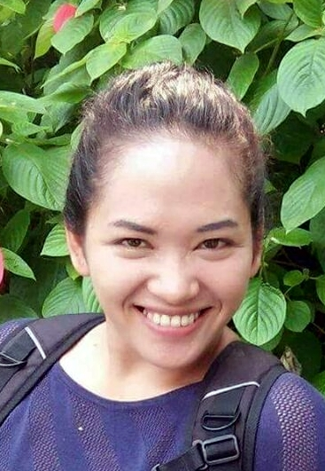

PERSONAL DATA

Name | Jeana M. Alvarez | Civil Status | Single
Gender | Female | No of children | -
Nationality | Filipino | Age of children | -
Date of Birth | November 29, 1990 | Age | 27
Place of Birth | Bago City, Negros Occ., Philippines | Height | 5’1”
Religion | Christian | Weight | 130 lbs

Elementary | Rosario Alvarez Elementary School
High School | Rammon Torres Malingin National High School
College | Northern Negros State College of Science & Technology
Other
EDUCATIONAL BACKGROUND YEAR

LANGUAGE PROFICIENCY

 | Language | READ | WRITE | SPEAK
1 | English
2 | Filipino
3 | Arabic
4

PAST EMPLOYMENT EXPERIENCE

Name and contact no of Employer | Location | From | To | Duties | Reason for Leaving
Abdulla Mohammad  Al Mulla | Qatar | 2014 | 2016 | Childcare, General Household Chores, Cooking (Arabic food) | Family reasons
Chan Sui Kei | Hong Kong | June 26  2017 | Present time | General Household Chores, Childcare, Cooking | Break contract due to being subjected to physical and verbal abuse

NON-DOMESTIC EMPLOYMENT EXPERIENCE

Company/Employer | Location | From | To | Job Title /Duties
SM Mall | Manila | 2012 | 2013 | Merchandiser
Red Star  Casting Agency | Amonas | 2013 | 2014 | Brand Ambassador

SUPPLEMENTARY INFORMATION
 | Yes | No
Willing to take care of new born babies
Willing to take care of children
Willing to take care of elderly
Willing to take care of male disabled person/elderly*
Willing to take care of female disabled person/elderly*
Willing to take care of pets
Willing to change day off
Known medical conditions (please specify below)
*Including bathing and help going to toilet/changing diapers

Available to start on:

Immediately after finding new employer
_________________________________________

Visa situation: Employed, visa valid until June 26, 2019

Have References? No

