Tel: 3486 3018
Mobile / Whatsapp: 9438 4535
E-mail: fairchoicehk@gmail.com

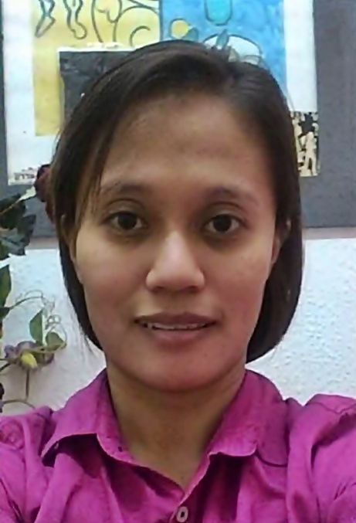

PERSONAL DATA

Name | Michelle O. Samparada | Civil Status | Single
Gender | Female | No of children | 2
Nationality | Filipino | Age of children | 7, 10
Date of Birth | September 15, 1985 | Age | 32
Place of Birth | Laguna, Philippines | Height | 5’2”
Religion | Roman Catholic | Weight | 49 kg

Elementary | Ricardo Pronove Elementary School | 1998
High School | Calumpang National High School | 2002
College | AMA Computer College
Other
EDUCATIONAL BACKGROUND YEAR

SKILLS

PREFERRED DUTIES

LANGUAGE PROFICIENCY

 | Language | READ | WRITE | SPEAK
1 | English
2 | Filipino
3
4

PAST EMPLOYMENT EXPERIENCE

Name and contact no of Employer | Location | From | To | Duties | Reason for Leaving
Mohammed  Al Saleh | Kingdom of Saudi Arabia | Jan  2012 | Jan  2015 | Childcare (3 & 7 y/o), General Household Chores, Cooking (Arabic) | Finished Contract

NON-DOMESTIC EMPLOYMENT EXPERIENCE

Company/Employer | Location | From | To | Job Title /Duties
Laguna Polymedic Hospital | Laguna | 2012 | 2015 | Polymedic Nursing Aide

INTERESTES / HOBBIES

SUPPLEMENTARY INFORMATION
 | Yes | No
Willing to take care of new born babies
Willing to take care of children
Willing to take care of elderly
Willing to take care of male disabled person/elderly*
Willing to take care of female disabled person/elderly*
Willing to take care of pets
Willing to change day off
Known medical conditions (please specify below)
*Including bathing and help going to toilet/changing diapers

Available to start on:

Immediately
_________________________________________

Visa situation: No visa, overseas hire from the Philippines

Have References?

